Crowdfunding

One conclusion we can draw is that of the categories, Film & Video, Music and Theater had the most successes by count. This could be attributed to the fact that these three categories make up a majority of the campaigns run, but they also have a higher success rate than we see from other categories.

Another conclusion we can draw solely by looking at this data is that journalism campaigns have a 100% success rate. However upon inspection we can see that only 4 campaigns were run in that category, which is far too small a sample size to draw a proper conclusion. In fact, of all the campaigns run, there are 4 categories that represent less than 5% of the data. With such small sample sizes I would recommend not drawing conclusions for any of Journalism, Food, Games, or Photography.

We can also see that the number of successes decreases between July and August. There is also a drop in failures and a slight uptick in cancellations, which shows us that the drop in successes does not correlate with the time of year but instead with a drop in the number of campaigns as a whole.

I also suggest including a Pie Chart like the screenshot below which adds another visual layer to the outcomes. It can be sorted by outcomes or category to help get a better idea of the relative success without being skewed by the contrast in data volume.
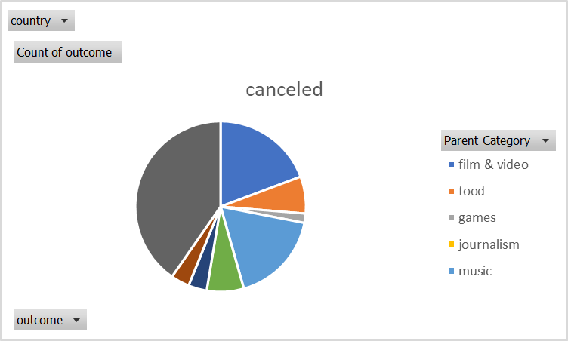

Statistical Analysis

Using a box and whisker plot (where blue represents successful backers and yellow failed) I found it much easier to compare the data visually. This leads me to the conclusion that the mean is a better representation than the median. Where X is the mean and the line is the median, we can see that in each case, the mean lies more closely to the center of the interquartile range. With the added benefit of outlier identification, the mean is clearly the better representation of the data.

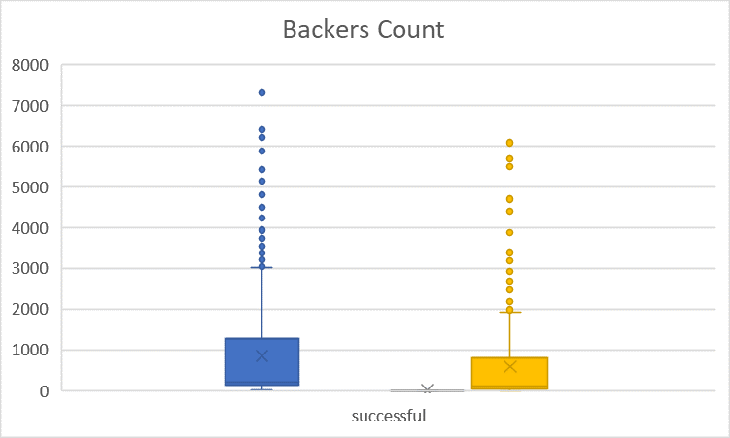

While the successful campaigns had a variability of 1,603,374, the failed campaigns had 921,575. We can see that the successful campaigns had far more variability. This makes sense because successful campaigns met and surpassed their fundraising goal, and there is no limit to how much can be raised beyond that. Therefore we would expect that the highest earning successful campaigns would greatly increase variance, while also expecting that the unsuccessful data set would be less spread out.

